ICT PROJECT DOCUMETATION

**Submitted To :**

**Laura Antochi**

**Submitted By : Team01**

**INDEX**

1. TEAM DESCRIPTION…………………………………………………………………...2
2. PROJECT DESCRIPTION………………………………………………………………..2
3. PROJECT AUDIT……………………………………………………………………………5
4. CLIENT AGREEMENT……………………………………………………………………7
5. PROJECT DEVELOPMENT…………………………………………………………….12
6. REFERENCES……………………………………………………………………………….24

**TEAM DESCRIPTION**

We Team 08 consists of four members, which includes

1. Chaithanya Krishna
2. Preetham Reddy Todima
3. Pruthvi Muniraj
4. Rohan Kunal Salla

We are developing a Mobile application for Universities Students. This is an application where we could analyse student’s ability to work in projects based on citizenship behaviour ,team work , leadership and work product .

**TEAM CONTRIBUTION**

|  |  |  |  |  |  |  |
| --- | --- | --- | --- | --- | --- | --- |
| **Team Member** | Planning | Documentation | Design | Research | Client Agreement | Prototype |
| **Chaithanaya Krishan** |  |  |  |  |  |  |
| **Preetham Reddy** |  |  |  |  |  |  |
| **Pruthvi Muniraj** |  |  |  |  |  |  |
| **Rohan Kunal Salla** |  |  |  |  |  |  |

**PROJECT DESCRIPTION**

**PROJECT JUSTIFICATION:**

The main intension to design this application is to estimate student’s ability towards working on a project based on certain criteria. Depending upon Citizen behaviour, user rate’s a mate on how promptly he arrives to group meetings, attends group meetings, completes his given work on time, if he is thoroughly prepared for group meetings and notifies in advance of late meetings .

Considering teamwork as criteria, user rate’s a mate on his behaviour in group discussion or how good he participates in group discussions , how creative he is while he offers an idea or suggest ideas, ready to criticism or answer questions , acknowledges expertise of others , to ensure he does not dominate group discussions, if he is willing to give and take suggestions , listens attentively to others and follows through deliverables.

Leadership, as most important criteria, the user rate’s a mate from Solicits divergent opinions which is estimated by others, shares his leadership goals with other members, suggests important issues for discussions, how good he keeps his discussion focused on key issues raised by clients, helps others when own work is finished and pulls a project together at the end.

Depending on the student’s Work product, the user can rate a mate on how good he can explain own work to others, corrects his own problems, how good he conducts research as needed to the project. The Student should be able to write in agreed upon style, check if submitted work Is complete, written work is professional, oral presentations is well rehearsed and output consistent with expectations

Considering average rating of all the criteria above the solution is gained by rating a student from the scale 0-5.

Depending on average scores the user decides if he wants to work or consider the student for the project followed by giving additional comments.

**PROJECT GOALS**

* The most important goal is to design and develop a mobile application for University Students.
* Provide Confidentiality for all the content and user profiles in the application.
* Design and develop functionalities according to the client requirement.
* Design better user interface with maximum effectiveness by avoiding unnecessary and unwanted options.
* To develop a highly efficient mobile app with minimum complexity in operation and quick and easier functionalities.

**PROJECT TIMELINE**

|  |  |  |  |
| --- | --- | --- | --- |
| **RELEASE VERSION** | **NO** | **FEATURES** | **DATE OF RELEASE** |
| **Alpha  5 weeks** | 1 | Profile | 29/05/2018 |
| 2 | Login |
| 3 | Change of details |
| 4 | Find a mate |
|  | 5 | Rate a mate |  |
|  | 6 | My rating |  |
| **Beta  5 weeks** | 1 | Monitoring/Admin | 15/08/2018 |
| 2 | Notify admin |
| 3 | Reply to rating |
| 4 | Notify new password |
| 5 | Notify user |
| **Final  5 weeks** | 1 | Message | 22/09/18 |
| 2 | Analytics |
| 3 | Security |
| 4 | Bug fixes |
|  |  |  |  |

The above table shows the project timeline based on three milestones and the release of three versions of the application as expected. It is expected to complete the project by the end of September 2018 and the proposed has been agreed by the client. We as a team is confident enough that we can achieve the proposed milestone on time. Additionally, we a group of four are not being over idealistic about as far as possible as we know our impediments and the aptitudes which we have, so we are as of now in track with the learning procedure and to convey the best of us.

Additionally, we assessed the days for every client stories as per its challenges and a lot of time has been distributed to different client stories as an appropriate testing will likewise be directed. In this way, unmistakably we will have the capacity to finish the task as indicated by the arrangement.

**PROJECT AUDIT**

AVAILABLE DAYS: 5*2*4 = 40(TEAM)

TOTAL ESTIMATED DAYS: 40 (PROJECT)

INDIVIDUAL AVAILABILITY: (2 DAYS/WEEK)

TOTAL NO OF WEEKS: 5

**MILESTONE 1: ALPHA RELEASE**

Alpha release is the first stage in the release of the mobile application and only the features which are mentioned below will be delivered in the estimated time.

USER STORIES: ALPHA

|  |  |  |  |
| --- | --- | --- | --- |
| **TITLE** | **DESCRIPTION** | **CLIENT PRIORITY** | **TIME ESTIMATE (DAYS)** |
| Login | User logins with his jc number and pre-defined password | 10 | 10 |
| Details change | Student Validate his/her student Id, email and password. Can also change his login credentials. | 10 | 10 |
| Find  a mate | User finds his mate by student id or number to rate him/her based on given scenarios | 20 | 10 |
| Rate  a mate | User rates from 0-5/ NA which can only be viewed by the user as an anonymous rating. | 20 | 10 |

The development for the Alpha release will start from the mid week of April 22-04-18 and it is expected to release on 29/05/2018.

Total of 40 days has been allocated for the Alpha development process and each one of the group member will spending one day per week for that 5 weeks. Which in turn will contribute to a total of 40 days.

**MILESTONE 2: BETA RELEASE**

Beta is the second stage in the development stage and it is estimated to complete and release the beta version on 09/07/2018. The time limit spared for the development of Beta version is also 5 weeks.

USER STORIES: BETA

|  |  |  |  |
| --- | --- | --- | --- |
| **TITLE** | **DESCRIPTION** | **CLIENT PRIORITY** | **TIME ESTIMATE (DAYS)** |
| My rating | User can see his own ratings.  Client gets a notification when his mate rates him/her. | 30 | 10 |
| Notify  new password | User receives an email to setup a new password if he wishes to change the pre-defined password. | 30 | 10 |
| Reply  to rating | User can reply to the ratings received.  User won’t be able to see the name of the mate who has rated him/her. But can reply to the ratings. | 30 | 10 |
| Admin Monitoring | Admin can see all the ratings and monitor them according to project priorities. | 40 | 10 |

Each team member will spend the same amount of time as in Alpha release and Beta version is also estimated to take 40 days.

**MILESTONE 3: FINAL RELEASE**

Milestone 3 is the final stage of the project and a fully functional mobile application is estimated to deliver at the end of this stage to the client. Final stage of development is also estimated to have 20 days and each team member will spend one day per week for 5 weeks.

USER STORIES: FINAL

|  |  |  |  |
| --- | --- | --- | --- |
| **TITLE** | **DESCRIPTION** | **CLIENT PRIORITY** | **TIME ESTIMATE (DAYS)** |
| Testing | Admin monitoring – App admin is able to see all the ratings and remove that are not legit . | 40 | 10 |
| Analytics | Notify admin if he/she suspects the rating received is not legit | 50 | 10 |
| Bug fixes | Security measures and fixing problems – Admin can perform testing and fix if any bugs in the app. | 50 | 20 |

**PROJECT DEVELOPMENT**

**GIT HUB** : Git hub or the configuration management is a tool in software development as multiple people are working on same project.

Slack is the version control tool which we are using for the development of this mobile application.

**PROJECT TOOLS**: Android studio as a software development tool which uses java scripting as a programming language .

SQl , PHP will be used for the back end and for server-side scripting.

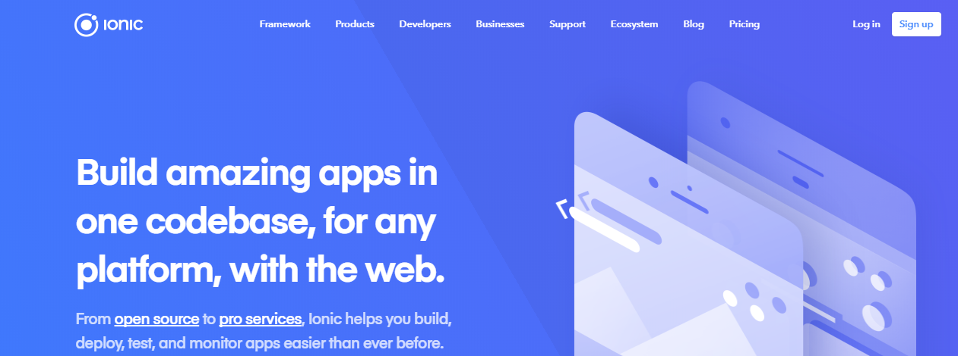

To setup a development environment for a developer in our team first we must install Android studio.

**TESTING TOOLS**:. SmartBear as a testing tool which is used to test application from other user feedback .

TestComplete Mobile is the testing tool which we are planned to test the application.

Also, the test will be conducted with the help of clients and with different user groups to collect the feedback at different stages of the development.

**SLACK CHANNEL:** Slack tool is used to communicate and manage the work within the team for the project.

**PROTOTYPES**

**REFERENCES**

* <http://business.sarinarusso.com>
* <https://www.employment.gov.au>
* <https://smartbear.com/product/testcomplete/mobile-testing/>
* <https://ionicframework.com/>